**SKILL DEVELOPMENT**

**Project Report**

**DLithe Consultancy Services Pvt. Ltd.**



**Project Report Assessment**

**Student Name: AISHWARYAE.M. GAWADA**

**Reg. no: 2JR23CS006**

**Assignment: Java**

**Organization:** DLithe Consultancy Services Pvt. Ltd.

**Supervisor’s Name: Archana SM**

## **Submitted to**

Signature of Training Supervisor Signature of Students

Date:

Date:

# TABLE OF CONTENTS

1. INTRODUCTION 1
2. BACKGROUND 7
3. TRAINING EXPERIENCE 7
4. KEY LEARNINGS 8
5. CHALLENGES 10
6. APPLICATION 10
7. CONCLUSION 11

INTRODUCTION

A password strength checker is a tool or algorithm designed to assess the security level of a password based on various criteria. In today's digital age, where cybersecurity threats are prevalent, ensuring strong password

practices is crucial for protecting sensitive information and maintaining data integrity.

Importance of Password Strength

Passwords serve as the first line of defence against unauthorized access to personal or sensitive data. A strong password significantly reduces the risk of brute-force attacks, where automated tools systematically attempt to guess passwords until they succeed. A robust password strength checker helps users and organizations enforce stringent password policies by evaluating the complexity and resilience of passwords.

Criteria for Assessing Password Strength

1. Length: The longer the password, the harder it is to crack. Passwords typically recommended are at
2. least 8 characters long.
3. Character Types: A strong password should include a mix of:
   * Uppercase letters (A-Z)
   * Lowercase letters (a-z)
   * Digits (0-9)
   * Special characters (such as !, @, #, $, etc.)
4. Avoiding Predictable Patterns: Passwords should not be based on easily guessable information, such as common words, sequences, or personal details.

How Password Strength Checker Works

A password strength checker algorithm evaluates these criteria to assign a rating to a password, typically

ranging from "Very Weak" to "Very Strong". Here's how it generally works:

* **Input**: Users enter their chosen password into the checker.
* **Evaluation**: The checker algorithm analyses the password based on its length and the presence of
* different character types.
* **Scoring**: Depending on how well the password meets the criteria, it assigns a strength score or

category (e.g., Weak, Strong).

Implementing Password Strength Checker

Password strength checkers can be implemented in various programming languages like Java, Python,

JavaScript, etc. They are often integrated into registration forms on websites, password management tools, or security software to guide users in creating strong passwords.

MINDMAP

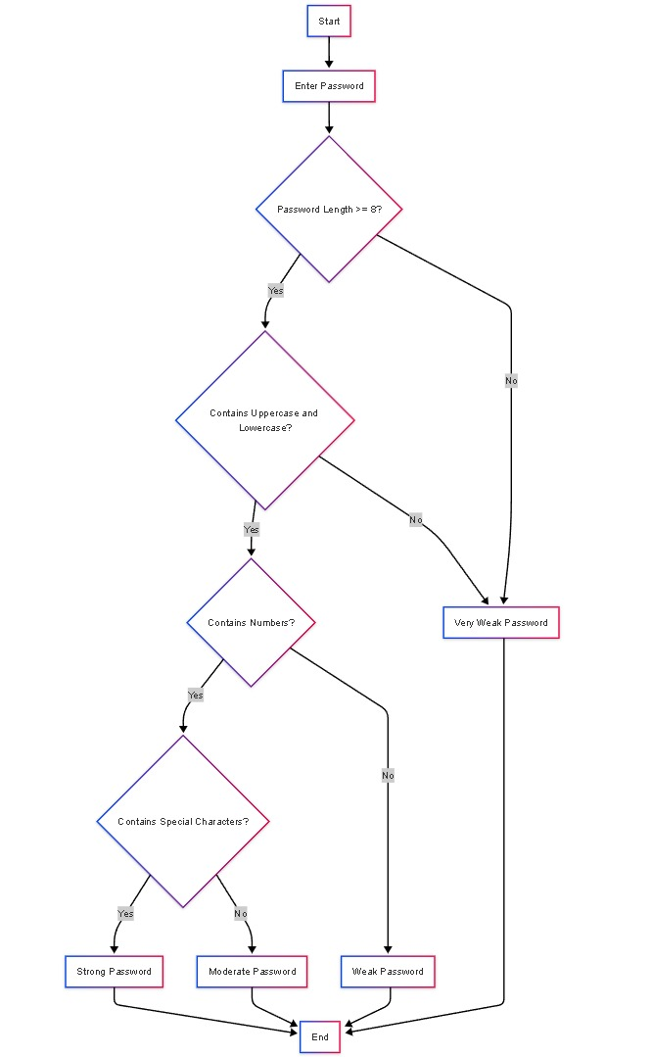

# **FLOW-CHART**

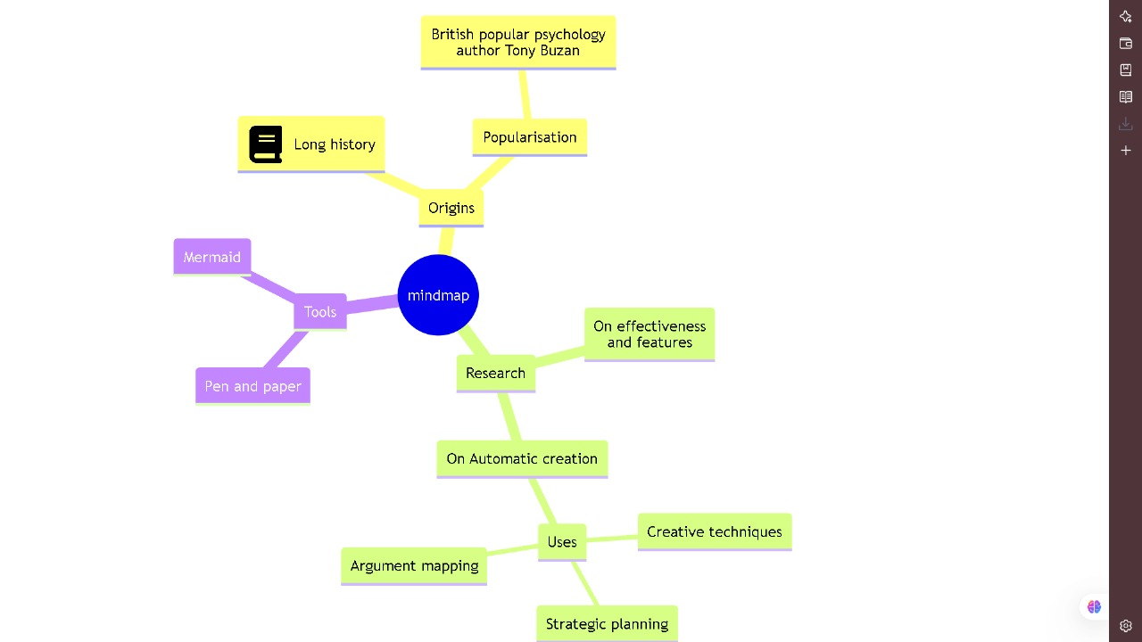

**Project Development Images**

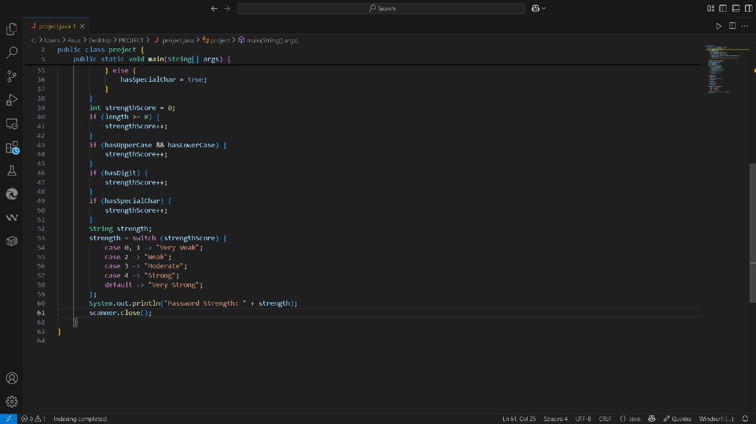

OUT PUT

## **Background**

Word frequency analysis is a core concept in natural language processing and data analysis.

Implementing such a function using core Java enhances understanding of string handling, loops, conditional logic, and user interaction. Adding a login mechanism simulates a real-world application where access control is important. In the field of computer science and data analysis, the ability to extract meaningful patterns from textual data has become increasingly valuable. One of the simplest yet most powerful techniques in text analysis is word frequency counting—identifying how often each word appears in a given body of text. This method serves as the foundation for more advanced applications such as sentiment analysis, topic modelling, keyword extraction, and natural language processing (NLP). Understanding the frequency of words in text can help identify important themes, detect redundancy, and even flag suspicious or repetitive content. The Word Frequency Counter project was developed to demonstrate how such analysis can be implemented using core features of the Java programming language. It is designed as a console-based application that accepts a paragraph of user-input text, processes it, and returns a structured count of each unique word. Before accessing the main functionality, users are required to authenticate themselves with a valid username and password, adding a basic level of security to the tool.

## **Training Experience**

Working on the Word Frequency Counter project provided a valuable and hands-on training experience in both programming and problem-solving using Java. Throughout the development process, I gained practical exposure to writing clean, logical, and efficient code for real-world applications. One of the key learning points was how to handle user input securely and accurately through input validation and authentication logic. Implementing a simple login system helped reinforce the importance of conditional structures and basic security considerations in application development.

of how natural language can be processed using programming tools. I also learned how to work with arrays and control flow to detect duplicate words and count their occurrences, which significantly improved my ability to write loops and nested conditions effectively. Debugging and testing the code played a major role in the learning process. Identifying logical errors and correcting them enhanced my problem-solving abilities and taught me the importance of careful code review.

Moreover, the experience of handling real-time in- put/output through the Java Scanner class helped me

## **Key Learnings**

### **Understanding Text Processing in Java**

One of the key takeaways from this project was learning how to process and manipulate text using core Java functions. The ability to handle string operations like converting text to lowercase, splitting text into words, and removing punctuation proved essential in normalizing the data for accurate analysis.

### **Working with Arrays and Collections**

The project reinforced the concept of using arrays (or advanced data structures like Array Lists and Hash Maps) to store and manage data efficiently. By using arrays to track word frequencies, I gained a better understanding of how data can be stored, accessed, and manipulated in Java.

### **User Authentication and Input Validation**

Implementing a basic user authentication system using a username and password provided valuable experience in input validation and conditional logic. It also highlighted the importance of ensuring secure access to sensitive features in any software system.

## **Technologies used**

### **Java Programming Language**

Used as the primary programming language for developing the application. Java was chosen for its portability, object-oriented structure, and rich standard library.

### **JDK (Java Development Kit)**

The Java Development Kit provides the essential tools and libraries needed to compile, debug, and run the Java application.

### **Java Console I/O (Scanner Class)**

The Scanner class from java.util package was used to read user input from the console, including username, password, and text data.

### **String Handling Functions**

Java's String methods like .to Lower Case (), split (), replace All (), and .equals() were utilized for text normalization and word comparison.

### **Arrays and/or Array List**

Arrays (or in advanced versions, Array List and HashMap) were used to store words and track their frequencies efficiently.

## **Use Case**

The Word Frequency Counter application allows authenticated users to input a block of text, processes it, and outputs the frequency of each unique word in that text. The user must first authenticate themselves with a valid username and password to gain access to the tool. After successful login, they can enter a block of text, and the system will return a list of words sorted by their frequency of occurrence.

## **Challenges**

### **Handling Case Sensitivity and Punctuation**

One of the initial challenges was ensuring that words were counted correctly despite variations in case (e.g., "Java" and "java") and punctuation. It required careful string manipulation to convert all text to lowercase and remove punctuation marks, which involved using regular expressions and string functions. Ensuring consistency in text processing was crucial for accurate word frequency counts.

### **Implementing User Authentication**

Implementing a simple authentication system with username and password validation posed some challenges in ensuring that incorrect credentials would stop further execution of the program.

Managing user input, validating credentials, and handling authentication failure gracefully required careful attention to input validation and error handling.

### **Efficiency in Word Counting**

Storing and counting words efficiently using arrays (or other data structures) presented challenges, especially when handling larger inputs. The initial approach of using simple arrays to store words could be inefficient for large datasets, which made me consider using more advanced structures like HashMap or Array List for better performance.

### **Dealing with User Input Errors**

Managing user input was another challenge, as I had to account for possible errors or invalid inputs, such as empty sentences or incorrectly formatted text. Ensuring the program would still work seamlessly with these edge cases required additional logic for input validation and error handling.

### **Managing Edge Cases**

Identifying and handling edge cases, such as sentences with no words or repeated words with

* + different delimiters, was a critical challenge. For example, I had to ensure the program could correctly count words in a text that included multiple spaces or unusual punctuation marks.

## **Applications**

The Word Frequency Counter tool, though simple in design, has a wide range of applications across various fields and industries. Here are some key areas where such a tool can be effectively applied:

### **Text Analysis and Data Mining**

In fields like data mining and text analytics, the Word Frequency Counter can help extract important information from large datasets. By identifying the most frequently used words in documents

### **Natural Language Processing (NLP)**

Word frequency counting is a fundamental task in NLP. It is often used as a preprocessing step in more advanced NLP tasks like sentiment analysis, topic modelling, and text classification.

### **Search Engine Optimization (SEO)**

In SEO, understanding the frequency of keywords is crucial. This tool can be used to analyse web pages, blog posts, or articles, helping content creators and marketers ensure that their content includes relevant keywords at optimal frequencies. It can also help in identifying keyword stuffing or areas where additional keywords may be needed.

### **Content Summarization and Keyword Extraction**

For journalists, researchers, and content writers, the Word Frequency Counter can help summarize a large body of text by identifying the most common words. It can also serve as a basic form of keyword extraction,

### **Conclusion**

The Word Frequency Counter project successfully demonstrates the practical application of fundamental programming concepts in Java. Through the implementation of text analysis and user authentication features, this project highlights the importance of string manipulation, loops, conditional logic, and array handling in solving real-world problems. By counting the frequency of words in a given text, the application not only helps users gain insights into the content but also serves as a valuable tool for analysing textual data in various domains such as journalism, education, and software development.